Admission Committee

- Description of the Committee:
The Admissions Committee at our B-school is a dedicated team entrusted with the responsibility of managing the admissions process with efficiency and transparency. Comprising experienced faculty members, administrative staff, and external stakeholders, the committee ensures a seamless experience for prospective students from application submission to final selection.

- Purpose of the Committee:
The purpose of the Admissions Committee is to streamline the admissions process and select candidates who demonstrate the potential to thrive in our academic environment and contribute positively to the B-school community. By upholding rigorous standards of evaluation and fostering inclusivity, the committee aims to attract a diverse cohort of talented individuals who align with the institution's values and goals.

- Objectives of the Committee: (In points)
- Develop and implement transparent and equitable admission criteria.
- Facilitate seamless communication with prospective applicants throughout the admissions cycle.
- Engage external stakeholders to contribute expertise and insights in the selection process.
- Ensure adherence to institutional policies, regulatory requirements, and accreditation standards.
- Identify and recruit candidates who exhibit academic excellence, leadership potential, and a commitment to personal and professional growth.
- Committee Members/ Composition:
S. No. | Name of Faculty | Designation | Committee Designation
1. | Aejaz Ahmed | Head, Training & Development | Convenor
2. | Dr. Hameed Kan | Associate Professor | Member
3. | Ms. Kalyani | Executive Assistant | Member

- Roles and Responsibilities of Members:
- Provide leadership and strategic direction to the committee.
- Oversee the overall admissions process and ensure adherence to timelines.
- Liaise with institutional leadership and external stakeholders on admission-related matters. Contribute expertise in curriculum design, teaching methodologies, and assessment practices to ensure academic rigor and quality.
- Contribute expertise in academic standards and program requirements.
- Review applications and participate in candidate evaluation processes.
- Conduct interviews and assess candidates' suitability for the program. Assist in organizing student-centric programs, workshops, and events to promote holistic student development.
- Manage administrative tasks related to application processing and documentation.
- Provide logistical support for admission events, interviews, and orientation sessions.
- Serve as a point of contact for prospective applicants and address inquiries effectively.Collaborate with the committee to facilitate industry partnerships, internships, and placement opportunities for students.
- Offer industry insights and perspectives to inform candidate selection.
- Participate as interview panelists or assessors in the admissions process.
- Advocate for the B-school within their professional networks and support recruitment efforts.
- Develop communication strategies and materials to promote admissions events and deadlines.
- Review applications and assess candidates' academic qualifications, work experience, and extracurricular activities.
- Conduct interviews, group discussions, or aptitude tests to evaluate candidates' skills and suitability for the program.
- Collaborate with faculty and staff to finalize admission decisions based on established criteria.
- Collect, analyze, and report on admissions data to track trends and inform decision-making.
- Generate reports on applicant demographics, conversion rates, and yield projections.
- Identify areas for process improvement and recommend strategies to optimize recruitment and retention efforts.
- Advocate for student interests and perspectives in the admissions process.
- Assist in organizing student-led initiatives to engage with prospective applicants.
- Provide feedback on the admissions experience and contribute ideas for enhancing student recruitment and retention.
- Serve as the primary point of contact for the admissions committee.
- Coordinate logistics for admissions events, interviews, and orientation programs.
- Maintain accurate records of applicant data, correspondence, and admission decisions.
- Promote diversity and inclusivity in the admissions process by implementing outreach initiatives to underrepresented groups.
- Review policies and procedures to ensure equitable treatment of all applicants.
- Provide training and resources to committee members on unconscious bias and diversity awareness.

- Frequency of Meetings:
Committee meetings are held on a Quarterly frequency.

- Procedure:
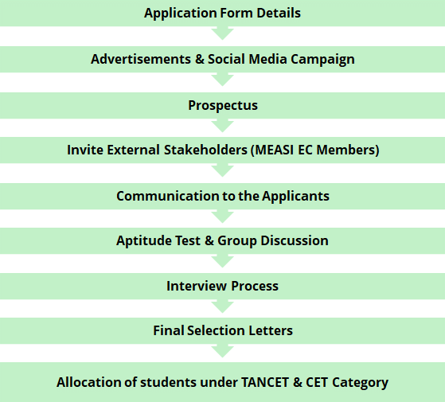

Details on Application Form:
- Design a comprehensive application form with sections for personal details, educational background, work experience, statement of purpose, and other relevant information.
- Include clear instructions for completing the application form, specifying required documents and supporting materials.
- Provide options for online submission and offline submission, along with designated submission channels and deadlines.
- Ensure that the application form captures all necessary information to assess candidates' eligibility and suitability for the program.

Advertisements:
- Develop compelling advertisements highlighting the B-school's unique selling points, academic programs, and admission criteria.
- Utilize diverse advertising channels such as print media, online platforms, social media, and recruitment fairs to reach a wide audience.
- Tailor advertisements to target specific demographics and regions to attract qualified candidates.
- Include contact information and instructions for accessing additional information or applying to the program.

Prospectus:
- Create a comprehensive prospectus outlining the B-school's mission, vision, academic programs, faculty profiles, infrastructure, and placement records.
- Provide detailed information on admission procedures, eligibility criteria, fee structure, scholarships, and financial aid options.
- Design the prospectus with visually appealing graphics and layout for easy readability and engagement.
- Distribute the prospectus through various channels, including online platforms, recruitment events, and information sessions.

External Stakeholder Involvement in the Selection Process (MEASI Trust Executive Committee Members):
- Invite MEASI Trust Executive Committee members to participate as interview panelists or assessors in the selection process.
- Provide orientation sessions to familiarize committee members with the B-school's admission criteria, program offerings, and institutional values.
- Assign specific roles and responsibilities to committee members, such as conducting interviews, evaluating candidates, or providing input on final selection decisions.
- Facilitate communication and coordination between the admissions committee and MEASI Trust Executive Committee members throughout the selection process.

Communication to the Applicants:
- Send personalized email communications to applicants acknowledging receipt of their applications and providing confirmation of submission.
- Provide regular updates on the status of their application, including information on interview invitations, test schedules, and admission decisions.
- Respond promptly to applicant inquiries and requests for clarification on admission procedures, eligibility criteria, and program offerings.
- Maintain open and transparent communication channels to ensure applicants feel informed and supported throughout the admissions process.

Aptitude Test and GD:
- Administer aptitude tests to assess candidates' analytical, quantitative, and verbal reasoning skills.
- Organize group discussion sessions to evaluate candidates' communication abilities, leadership potential, and teamwork skills.
- Designate qualified faculty members or external experts to facilitate aptitude tests and GD sessions.
- Establish evaluation criteria and scoring mechanisms to objectively assess candidates' performance and suitability for the program.

Interviews:
- Schedule interviews with shortlisted candidates based on their application profiles and assessment results.
- Conduct structured interviews to assess candidates' academic background, work experience, career goals, and alignment with the B-school's values.
- Assign interview panels comprising faculty members, alumni, and industry professionals to evaluate candidates' potential for success in the program.
- Document interview outcomes and feedback to inform final selection decisions.

Final Selection Letters:
- Prepare personalized final selection letters for successful candidates, confirming their admission to the B-school.
- Include details such as the program of study, commencement date, fee payment instructions, and enrollment deadlines.
- Provide information on orientation programs, campus facilities, and support services available to admitted students.
- Encourage accepted candidates to confirm their acceptance and complete the enrollment process within the specified timeline to secure their seat in the program.

TANCET & CET Examination Category Students:
- Provide guidance and support to candidates preparing for state-level entrance exams such as TANCET (Tamil Nadu Common Entrance Test) and CET (Common Entrance Test).
- Offer preparatory classes, study materials, mock tests, and counseling sessions to help candidates excel in the entrance exams.
- Assist candidates in navigating the application process for the B-school, including submission of exam scores and supporting documents.
- Consider TANCET & CET examination scores as part of the overall assessment criteria for admission, along with other academic qualifications and selection criteria.

Amended Date/s |  | Revision Number:
Prepared By: | Aejaz Ahmed | Approved By:

